**Coding Iteration 3 manual**

*Created by:* Maya Castiblanco, Haley Coleman, Anjana Lakshmi

*Last Updated:* Jan 2nd, 2023

The purpose of this study is **<not blind>**

**Verbal Code 3_VC3**

1. **For each participant file, download:** (a) [the audio-only file](https://uchicago.box.com/s/pm7bnh2sly6tx9kpbiy25mb5imans2hx) and (b) [the Level 2 coded file](https://uchicago.box.com/s/4mnyp8agg9iocqp0hxdnapw0hsq53f6y) [or you can open the file without a linked file and add the audio-video file later]
2. **Open the Level-2 coded file:** It will automatically open the audio file as well on ELAN. Rename it as a Level-3 coded file <participant_id>_VC3_your coder number
3. **Summary of ELAN Tiers**

At the time of coding, the verbal coders should have completed the VC2 codes. Use the completed VC2 codes to begin the VC3 codes. The completed VC2 codes should look like the following:

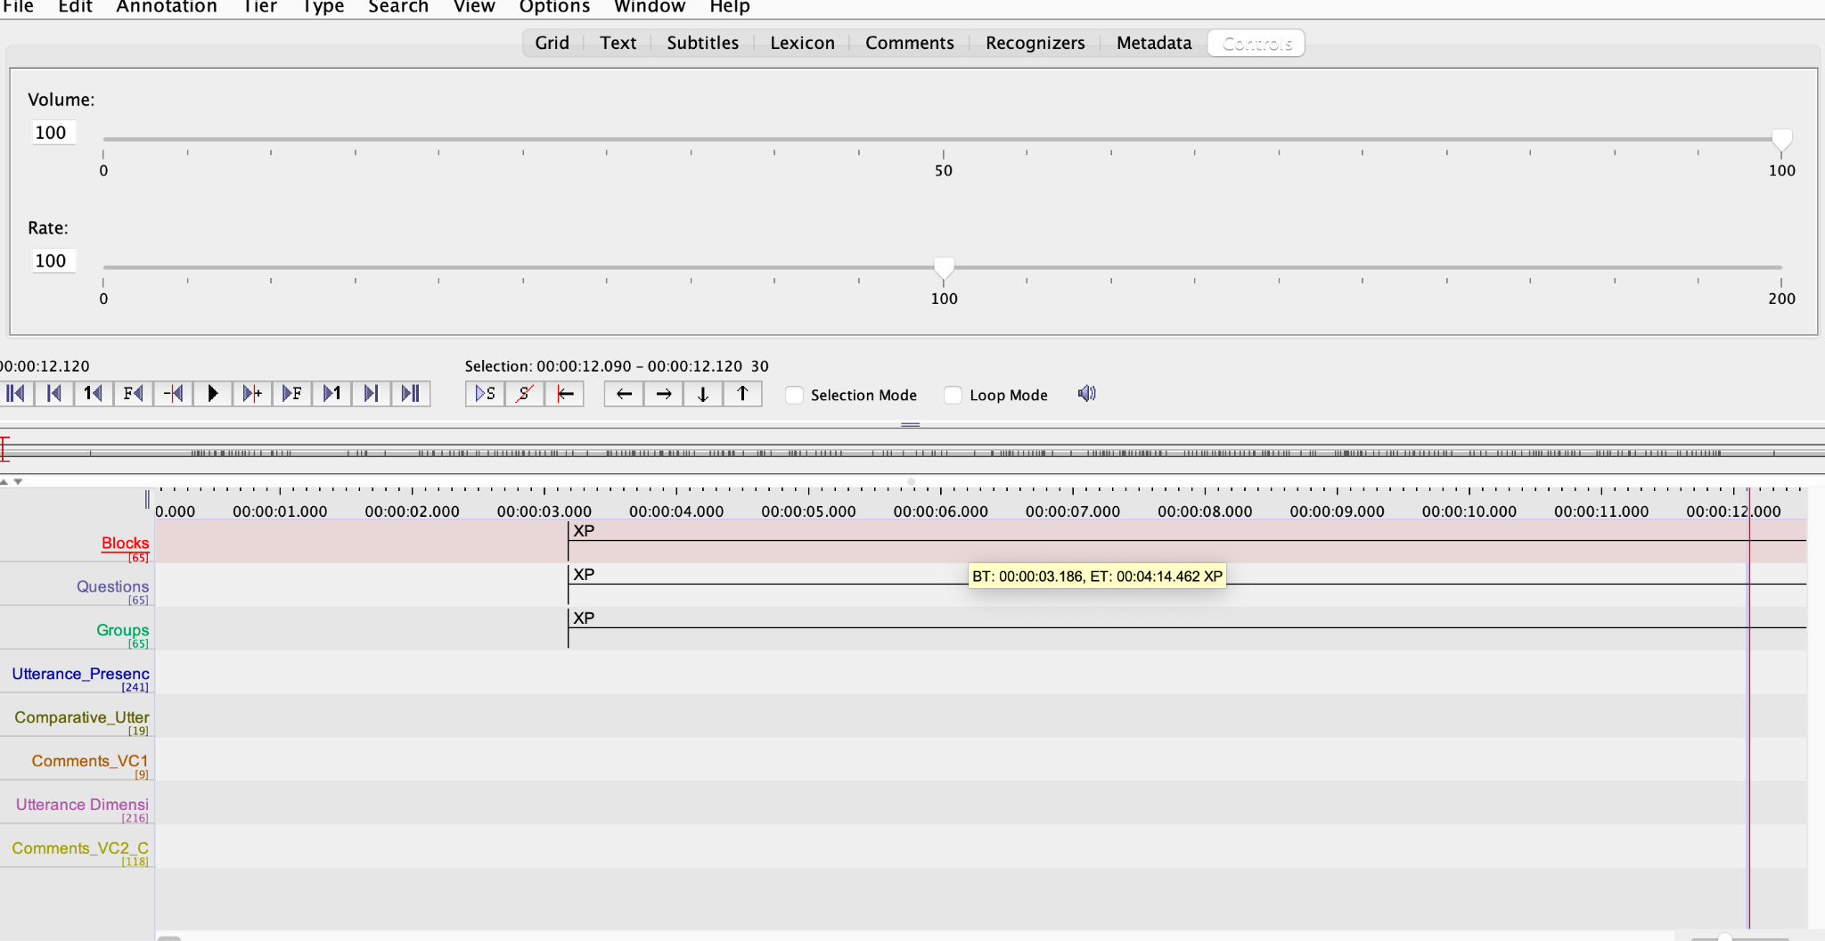

As seen above, the completed VC2 codes should have the following tiers: BLOCKS, QUESTIONS, GROUPS, UTTERANCE_PRESCENCE, COMPARATIVE_UTTERENCE, COMMENTS_VC_UTTERANCE DIMENSION, and COMMENTS VC

1. **Import Template File**

To import template file, go to Tiers --> Import Tiers. In the pop up window select the “SG_VC3_Template.etf” file. Click on “Import” and then “Close.” This should result in the import of 4 new tiers: Coder Here, Code First, Error, and Comments.

1. **Description of ELAN Tiers**

Code Here

Possible Values: Yes/ No/ Maybe

Description: This tier will inform gesture coders to only gesture code where there is verbal data of interest to this study.

Code First

Possible Values: Yes/ No/ Maybe

Description: This tier will inform gesture coders to only gesture code where there is verbal data of *immediate* interest to this study.

Error

Possible Values: Yes/ No/ Maybe

Description: Mark "Yes" in the "Error" tier if you suspect the gesture is indexing not warmth or competence but something else in the utterance. **Do NOT let this**  **be a reason to remove the annotation from "Code Here" or "Code First"**  **tiers - the annotation stays for gesture coding!** This is just an additional layer of coding - we can analyze the data with and without these and see what happens.

Comments

Possible Value: No vocab- use default

1. **Annotate the "Code Here" tier**

Copy all relevant annotations from the "Utterance Dimension" tier onto the "Code Here" tier. "[Tier -> Copy annotations from tier to tier](https://www.mpi.nl/corpus/html/elan/ch02s13s03.html)" menu option. In the window that opens when you choose this menu option, select "Utterance

Dimension" as the source, "Code Here" as destination and then copy paste the

following codes when it asks you if you want to copy annotations with specific

values:

1 (HW)

2 (LW)

3 (HC)

4 (LC)

1S (HW -S)

2S (LW -S)

3S (HC -S)

4S (LC -S)

*TIP: make sure the “treat as regular expression” box is not selected

1. **Annotate the "Code First" tier**

Copy all annotations from "Code Here" to "Code First."

Zoom into the “Code First” tier to see the label (listed below)

Only mark an annotation as "Yes" here if the utterance matches one of the following criteria:

|  |  |  |
| --- | --- | --- |
| Group | Name | Mark "Code First" Only If |
|
| 1 | Doctors | HC, HC - S |
| 2 | CEOs | HC, HC - S |
| 3 | Blind People | LC, LC - S |
| 4 | Unemployed People | LC, LC - S |
| 5 | Nurses | HW, HW - S |
| 6 | Children | HW, HW - S |
| 7 | Politicians | LW, LW - S |
| 8 | Homeless People | LW, LW - S |

If the utterance is about another group or with a different dimension code, mark "No" for the

"Code First" tier. Remember that these criteria (whether the utterance is about these specific groups) do not matter for you annotation for the “Code Here” tier.

For example, if the Group is "Doctors" (coded as "1" in the tier "Groups") the "Code Here" tier will have all warmth-competence dimensions coded within this group, but the "Code First" tier will have only "HC" or "HC - S" annotations.

On the other hand if the "Groups" tier has a group comparison (coded as "10" for example) or the annotation refers to the warmth of Doctors, the "Code Here" tier will say "Yes" anyway because warmth is relevant for this study, but the "Code First" tier should not.

Helpful Hint: In ELAN, go to options> Annotation Mode> Grid> Click on Groups and then do the CODE HERE tier. This will align the group tier with the correct Utterance dimension.

Ultimately, both the “Code Here” and “Code First” tiers should only have “Yes” or “No” labels.

1. **Delete "No" codes**

Get rid of any “No” codes by **Tier_ Remove Annotations or Values_ Code First_ Annotations where the value is_ No**

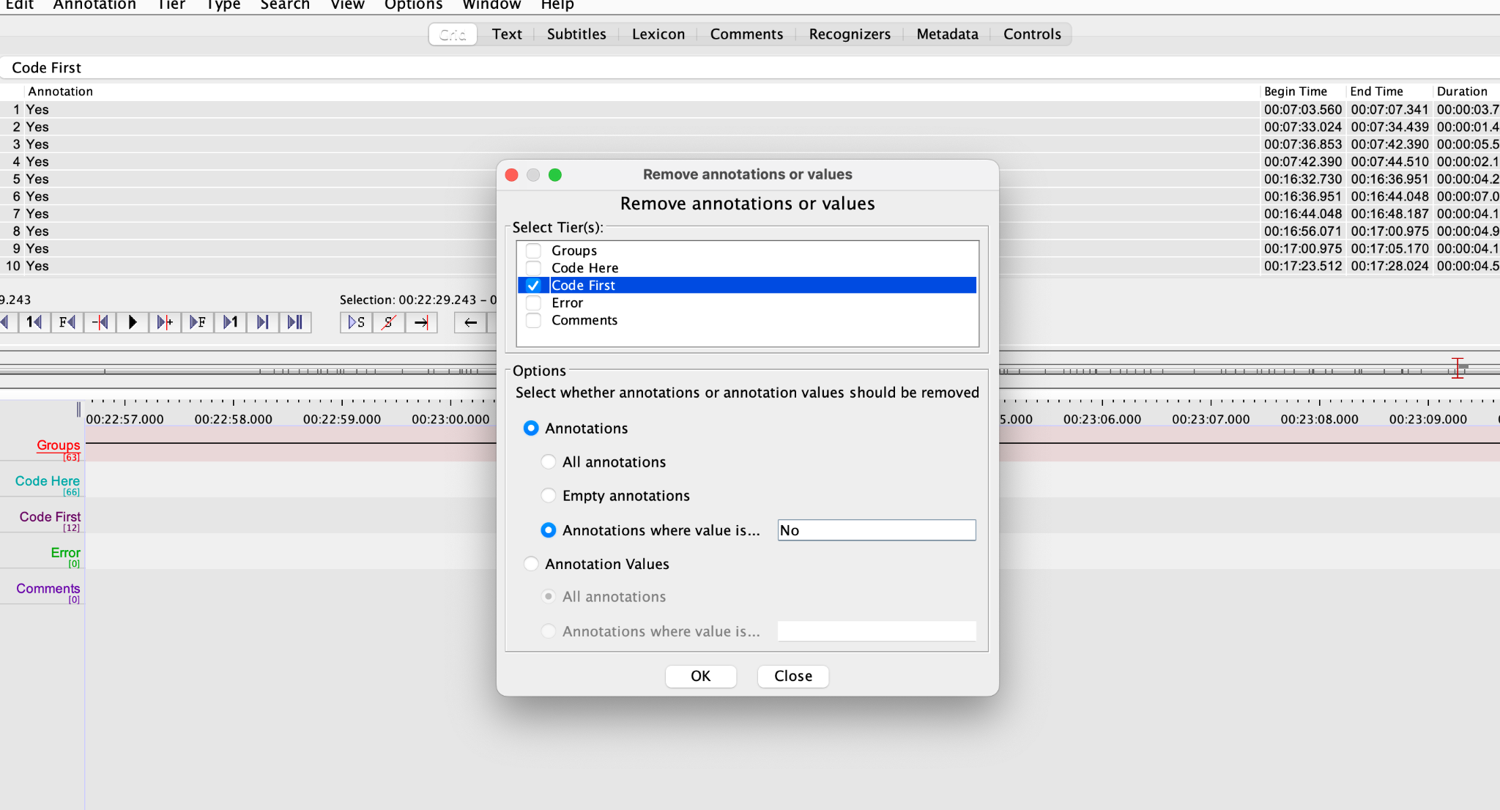

1. **Unlink the audio file and link the audio-video file**

To unlink the audio file and link the audio video file, go to **Edit_Link**  **Files**_Click on the present file_ **Remove** it_ then select **Add**. Find the video that matches the participant ID Number, upload it, and select **Apply**

1. **Adjust boundaries**

Go through the annotations you've coded as "Yes" in “Code Here” and adjust boundaries in case the utterance boundaries cut through an ongoing gesture movement. Next, adjust the “Code First” boundaries accordingly.

Tip: this is a great time to check your annotations!

Note on adjusting boundaries: 1. If the other gesture is not HW/HC/LW/LC/HW-S/HC-S/LW-S/LC-S, that is okay. This is because we are not going to analyze anything except for these codes at present - see below:

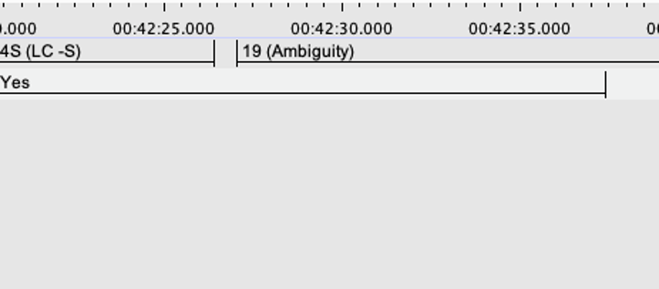

2. If the other gesture is HW/HC/LW/LC/HW-S/HC-S/LW-S/LC-S, leave the boundaries as is. In the following example, the first two annotations are problematic: In R, the small fraction of LC-S that leaks into HC-S will be treated as an additional HC-S utterance. Say the gesture coders mark HC-S as gestureA and LC-S as gestureB, the code will count this as one gestureA for HC-S, one gestureB for LC-S and a gestureB for LC-S.

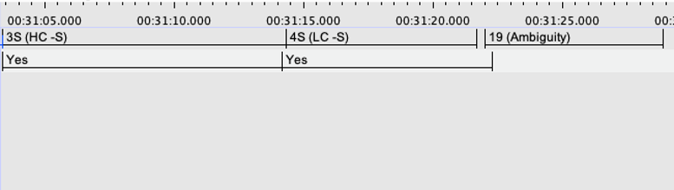

The second and third are better to avoid, but fine if it happens once in a while. It is true that gestureB will be counted twice by R (one for Ambiguity), it will not be included in the analysis though, and therefore we should be fine.

1. **Save a copy of your ELAN file as <Participant ID>_VC3_<Coder ID>_ForVerbal**
2. **Save another copy of your ELAN file as <Participant ID>_VC3_<Coder ID>**
3. **Delete unwanted tiers in file <Participant ID>_VC3_<Coder ID>**

The only tiers that should be visible are: **"Code Here"** and **"Code First"**

1. **Upload your finished files – make certain the Gesture Coders only receive the <Participant ID>_VC3_<Coder ID> and not the <Participant ID>_VC3_<Coder ID>_ForVerbal file.**